F NOJSC KMU 4/3-01/1

NON-COMMERCIAL JOIN-STOCK COMPANY
«KARAGANDA MEDICAL UNIVERSITY»

APPROVED BY
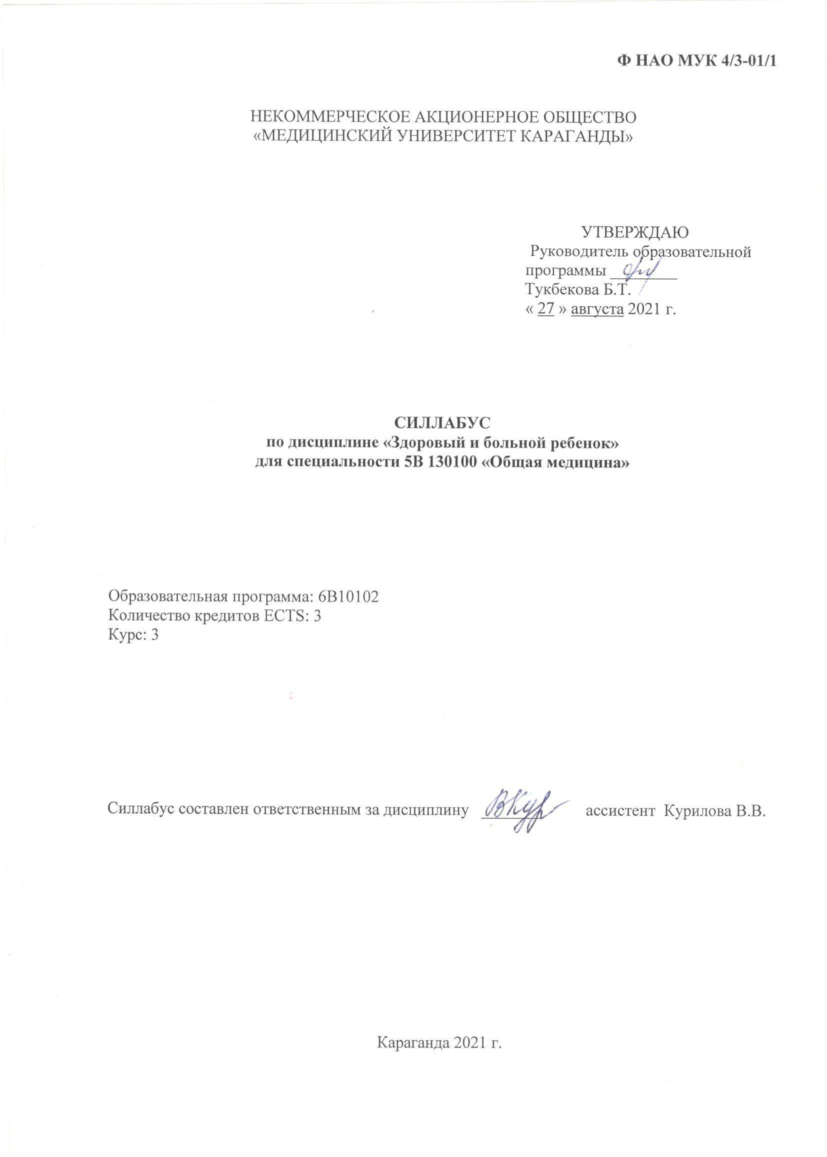
Director of educational program
________ prof. Tukbecova B.T.

«_28_» august 2024 year

SYLLABUS
in the discipline «Healthy and Sick Child»
for specialty 6В10113 «Medicine»

Educational program: 6B10113
Number of credits ECTS: 3
Course: 3


The syllabus is drawn up by the discipline officer _____________ ass. Kurilova V.V.

Karaganda 2024 year

Description of the discipline

Name of the discipline |  |  |  |  | Code |  | Educational program
Healthy and Sick Child |  |  |  |  | 6В10113 |  | Healthy and Sick Child
Teachers |  |  |  |  | Structural division
Responsible: Kurilova V.V. |  |  |  |  | Department of Pediatrics and Neonatology
Teachers: 4
Training level |  |  | View |  |  |  | Module (s)
Bachelor course |  |  | PD ВК |  |  |  | Healthy and Sick Child
Forms of conducting classes |  |  |  |  |  |  |  | Training period
Practical classes, lectures, SIW, SIWT.CSET |  |  |  |  |  |  |  | V –VІ semester
Mandatory prerequisites: |  |  |  | Additional prerequisites:
1) apply their knowledge, understanding and abilities at a professional level to solve problems in pediatrics, in a broader interdisciplinary context;  2) to collect and interpret information for the formation of judgments, taking into account social, ethical and scientific considerations;  3) clearly and unambiguously communicate information, ideas, conclusions, problems and solutions, both to specialists and non-specialists;  4) learning skills necessary for independent continuation of further education in the field of study.  5) apply knowledge of cardiology, pharmacology and children's diseases. |  |  |  | Demonstrate developing knowledge and understanding in the field of study, including elements based on advanced knowledge of the field.  Invite students to study childhood diseases and elective disciplines in pediatrics.
ECTS | Hours | Lectures | Practical lesson,hours. |  |  | SIWT, h.. |  |  | SIW, h... | MА, ч.
3 | Healthy and Sick Child 90 | 3 | 24 |  |  | 18 |  |  | 36 | 9
of them | CSET 15 |  | 5 |  |  | 3 |  |  | 5,5 | 1,5
The purpose of the discipline
Formation of students' high motivation in acquiring knowledge about the anatomical and physiological characteristics of organs and systems of the child's body, master the methodology for assessing the physical development of children in the age aspect, mastering the skills of collecting complaints and anamnesis, mastering the method of physical examination of children of different ages. To teach students the peculiarities of interaction with a sick child and his legal representatives.
All this is necessary for high-quality professional training for the follow-up of a doctor.
Summary of the discipline (up to 300 characters)
"Healthy and Sick Child" is the first clinical discipline in which students learn for the first time how to deal with children and their parents in a children's health care setting.
Teaching this discipline will prepare competent specialists in the field of medical care for the child population. Knowledge of the patterns of growth in the development of the child's body, the peculiarities of the methodology for researching a child will expand the understanding of future general practitioners about the features of working with children, create the prerequisites for training pediatric specialists. The curriculum of the discipline contains systematized scientific knowledge about the periods of a child's life, the criteria of biological age, about the principles of a healthy lifestyle based on rational nutrition and a properly organized regimen in children of different age groups.
Clinical criteria for assessing the state of a healthy and sick child, methods for assessing the physical development of children, and dietary habits of children of different age groups are studied.
When studying the discipline, students receive information about the clinical criteria for assessing the state of a healthy and sick child, about the anatomical and physiological characteristics of the development of the child's body in different age periods, information about the methodology for collecting anamnesis and objective research of the child. The semiotics of organ damage and malformations of various organs are studied. It is important to lay down and develop in students ethical and deontological principles of relationships, communication skills with a healthy and sick child and their parents of the child, with medical personnel, observe the medical-protective and sanitary-anti-epidemic regime of children's institutions. University students in the process of mastering the necessary knowledge and practical skills that will be required in their professional activities.
Academic Integrity Policy
Academic integrity is the basis of the organization of the educational process and is ensured by clear, fair and objective standards defined by the Academic Policy of the university and this syllabus. The promotion and protection of academic integrity are the result of joint efforts of students and teachers. Within the framework of the discipline, all written works, regardless of their nature, content and volume, will be checked for originality through automated systems for checking for plagiarism. If plagiarism is detected, violations of the university's rules for quoting other people's and their own works, as well as other violations of academic integrity provided for by the Code of Academic Integrity, appropriate measures will be applied.
Discipline policy (up to 300 characters)
Particular attention is paid to the behavior of students in the clinic, their compliance with the medical and protective regime of the departments, compliance with the rules of ethics and deontology.
At the first lesson in the discipline, the basic level of knowledge of the student is assessed. The assessment for basic knowledge is put down in the educational journal on a 100-point scale. The baseline score is not taken into account when calculating the TR. Current grades for the student are given by the teacher in the educational journal on a 100-point scale for each completed task / section (an integrated topic, which may include several lessons). All types of educational work (classroom and extracurricular) are taken into account when setting the current grade for an assignment / credit. There are 1 marks, at the end of each credit, 3 marks for the discipline Healthy and Sick Child.
At the last lesson in the discipline Healthy and Sick Child, a written examination is carried out, the entire volume of material is covered, including questions, practical lessons, SIW, SIWT.CSET. Lessons missed for no valid reason are not completed. If the number of hours of absence is 50% or more of the total number of hours allotted for practical classes related to this task / section, the student is not allowed to submit the task / section. "0" is put in the electronic journal.
Classes that were missed only for a good reason are worked out.
1) Grading policy: Each credit in the module ends with the assignment of a grade for the task / section, for a total of 3 marks for the discipline. The grade for the task / section is calculated as the arithmetic mean of all components: 1 grade for PL + 1 grade for SIWT + 1 grade for SIW.
2) The working rules are determined by the policy: Regulation on the rating system for assessing student progress (development date 05/13/2019).
3) Compulsory attendance of types of classes by students: must attend all types of classroom classes - practical and seminar classes, performs all SIWT and SIW.

Final Learning outcomes
TR from educational program (code ) | TR of discipline | Methods of training | Measures for assessment
6В10102 | 1) results  learning - written exam | Practical lesson: thematic analysis, seminar TBL, CBL, SIWT. SIW | final examination  End of semester exam:  1) Written exam

Thematic plan

№ п/п | Chapte | The name of the theme | Number of training hours: |  |  |  |  |  |  | Tasks  (can combine several topics, but not less than 1 and not more than 3 current tasks for credit; the total number of tasks in the discipline, not less than 5)
 |  |  | Lectures | PL | SIWT | SIW | MА |  | SIWT
Credit 1.
1. |  | Extra- and intrauterine stages and periods of child development. Features of the physical development of infants and young children, children over 3 years old. Principles for monitoring the development of young children. |  | 2
2. |  | Psychosocial development of children. Early childhood developmental care. Providing a safe environment. Features of interaction with a sick child and his legal representatives |  | 2
3 |  | Embryogenesis, anatomical and physiological features of the musculoskeletal and muscular system in children. Characteristics of the skin. Semiotics of skin lesions arising during the neonatal period. |  | 2
4 |  | Semiotics of lesions of the muscular system in children (hypotrophy, atrophy) Violation of muscle tone. Myopathy  Semiotics of damage to the skeletal system and joints in children (developmental anomalies, pain in bones and joints, deformities) |  | 2
5. |  | Procedures for anthropometric research and physical development of young children. Methodology for assessing the physical development of children over 3 years old and adolescents. |  |  | 1
6. |  | Providing advice to parents / legal representatives of children on preventing accidents in children and identifying cases of abuse and violence against children |  |  | 2
7 |  | Research methodology of the muscular system in children. Assessment of muscle tone in newborns.  Joint research technique, shape, size, range of motion, pain |  |  | 1
8. |  | Research methodology for examining the skin and mucous membranes, skin appendages and subcutaneous adipose tissue in children. |  |  | 2
9. |  | Neuropsychic development of young children. Stages of motor development of speech, criteria for assessing performance. Windows of achievements in motor development of children. |  |  |  | 4
10. |  | Healthy baby food. Natural feeding. The principles of natural feeding. Benefits of breastfeeding. Introduction of complementary foods, basic requirements. Semiotics of malnutrition. |  |  |  | 4
11. |  | Deviations in the development of the musculoskeletal system and joints. Features of phosphorus - calcium metabolism in children, its regulation. The daily requirement of children of different ages for calcium, phosphorus, vitamin D2. |  |  |  | 4
 |  |  |  | 8 | 6 | 12 |  |  | 26
Credit 2
12. |  | Embryogenesis, anatomical and physiological features of the respiratory system in children. Semiotics of congenital malformations, lesions of the respiratory system in children. | 1 | 1
13. |  | Embryogenesis, anatomical and physiological characteristics of the heart in children. Semiotics of congenital heart defects, damage to the cardiovascular system in children. |  | 1
14. |  | Embryogenesis, anatomical and physiological features of the blood and the hematopoietic system in children of different ages. |  | 1
15 |  | Anatomical and physiological features of lymph nodes in children. Groups of lymph nodes. Semiotics of lymph node involvement. |  | 1
16. |  | The method of physical examination of the respiratory system in children of different ages. Percussion. Auscultation |  | 1 | 2 | 2 | 0,5 |  |  | ЦСОТ
17. |  | Method of physical examination of the cardiovascular system in children of different ages. Percussion, auscultation |  | 1 | 3 | 3,5 | 1,0 |  |  | ЦСОТ
18 |  | Features of the hemogram of healthy and sick children of different ages. |  |  | 1
19. |  | Method of physical examination of lymph nodes in children |  |  | 1
20. |  | Anatomical and physiological features and features of the methodology for examining the sensory organs in children. Hearing and vision testing of a child |  |  |  | 2
21. |  | Nutrition of a sick child. Diet for various diseases in children. Diet tables. |  |  |  | 2,5
22. |  | Blood coagulation system. Features of hemostasis in newborns. Fibrinolysis |  |  |  | 2
 |  |  | 1 | 6 | 7 | 12 |  |  | 26
Credit 3
23. |  | Embryogenesis, anatomical and physiological features of the digestive system in children. The method of physical research and semiotics of congenital malformations of the digestive system in children. | 1 | 2
24. |  | Embryogenesis, anatomical and physiological features of the kidneys and urinary system in children. Physical examination technique and semiotics of congenital malformations, kidney and urinary tract damage in children | 1 | 1
25. |  | Embryogenesis, anatomical and physiological features and an algorithm for examining the endocrine system in children of different ages. Semiotics of endocrine system damage. |  | 1
26 |  | The immune system in children. Nonspecific and specific defense mechanisms. Semiotics of damage and an algorithm for examining the immune system in children of different ages |  | 2
27. |  | Features of digestion in children. Methodology for physical examination of the digestive system in children |  |  |  | 3
28. |  | Functional features of the urinary system in children. Method of physical examination of the kidneys and urinary system in children |  |  | 3
29. |  | The method of physical examination of the endocrine system in children of different ages. |  |  |  | 3
30. |  | Semiotics of damage to the immune system in children. Primary and secondary immunodeficiency states. |  | 2 | 2
36. |  | Laboratory and instrumental methods for the study of the gastrointestinal tract in children. Methods for the diagnosis of orphan diseases. |  |  |  | 3
37. |  | Laboratory and instrumental methods of studying the kidneys and urinary system in children. |  |  |  | 3
38. |  | Laboratory and instrumental methods for studying the endocrine system in children. |  | 2
 |  |  | 2 | 10 | 5 | 12 |  |  | 29
Total: |  |  | 3 | 24 | 18 | 36 | 9 |  | 90
Grading scale

Letter grade | Digital equivalent of assessment | Percentage of assessment | Traditional assessment
А | 4 | 95-100 | "Great"
А- | 3,67 | 90-94
В+ | 3,33 | 85-89 | "Good"
В | 3,0 | 80-84
В- | 2,67 | 75-79
С+ | 2,33 | 70-74
С | 2,0 | 65-69 | "Satisfactorily"
С- | 1,67 | 60-64
D+ | 1,33 | 55-59
D | 1,0 | 50-54

Knowledge assessment criteria
An “excellent” grade is given if the student has demonstrated complete mastery of the program material and has not made any errors or inaccuracies, completed tests and laboratory work in a timely and correct manner and submitted reports on them, and has shown original thinking in a timely manner and without any - made mistakes, passed colloquiums and completed homework, was engaged in research work, independently used additional scientific literature when studying the discipline, and was able to independently systematize program material.
A “good” grade is given if the student has mastered the program material no less than 75% and has not made any gross errors in answering, completed tests and laboratory work in a timely manner and passed them without fundamental criticism, completed them correctly and passed them on time colloquiums and homework without fundamental comments, used additional literature as directed by the teacher, engaged in research work, made unprincipled inaccuracies or fundamental errors corrected by the student himself, managed to systematize program material with the help of the teacher.
A “satisfactory” grade is given if the student has mastered the program material by at least 50%, needed the help of a teacher when completing tests and laboratory work, homework, made inaccuracies and non-fundamental errors when passing the colloquium, and was not active in research. work, limited himself only to educational literature indicated by the teacher, and experienced great difficulties in systematizing the material.
An “unsatisfactory” grade is given if the student has discovered gaps in the knowledge of the basic material provided for by the program, has not mastered more than half of the discipline program, made fundamental errors in his answers, has not completed individual tasks provided for in the forms of current, intermediate and final control, has not worked all basic literature provided by the program.

Criteria for evaluation

Valuation strategy (valuation type) | Weight (in%) | Deadline for the assignment | Evaluation criteria
current control - solving situational tasks, interpretation of analyzes, assessment of practical skills at the patient's bedside | 60% | Tasks for the SIWT, SIW are handed over by the student to the teacher leading the classes in the discipline, on the days and hours provided for the thematic plan of the discipline | Each credit in a module ends with a grade for the assignment / section. The grade for the task / section is calculated as the arithmetic mean of all components: 1 grade for PL + 1 grade for SIWT + 1 grade for SIW.
final control | 40% | School of Medicine Schedule | A written exam
Note: The student's academic rating (ARO) consists of an admission rating (RA), which is established by calculating the arithmetic average of all current grades and is 60% in the ARC and the final control rating (RIN), which is 40% in the ARC. The admission rating for the discipline should be at least 50%.

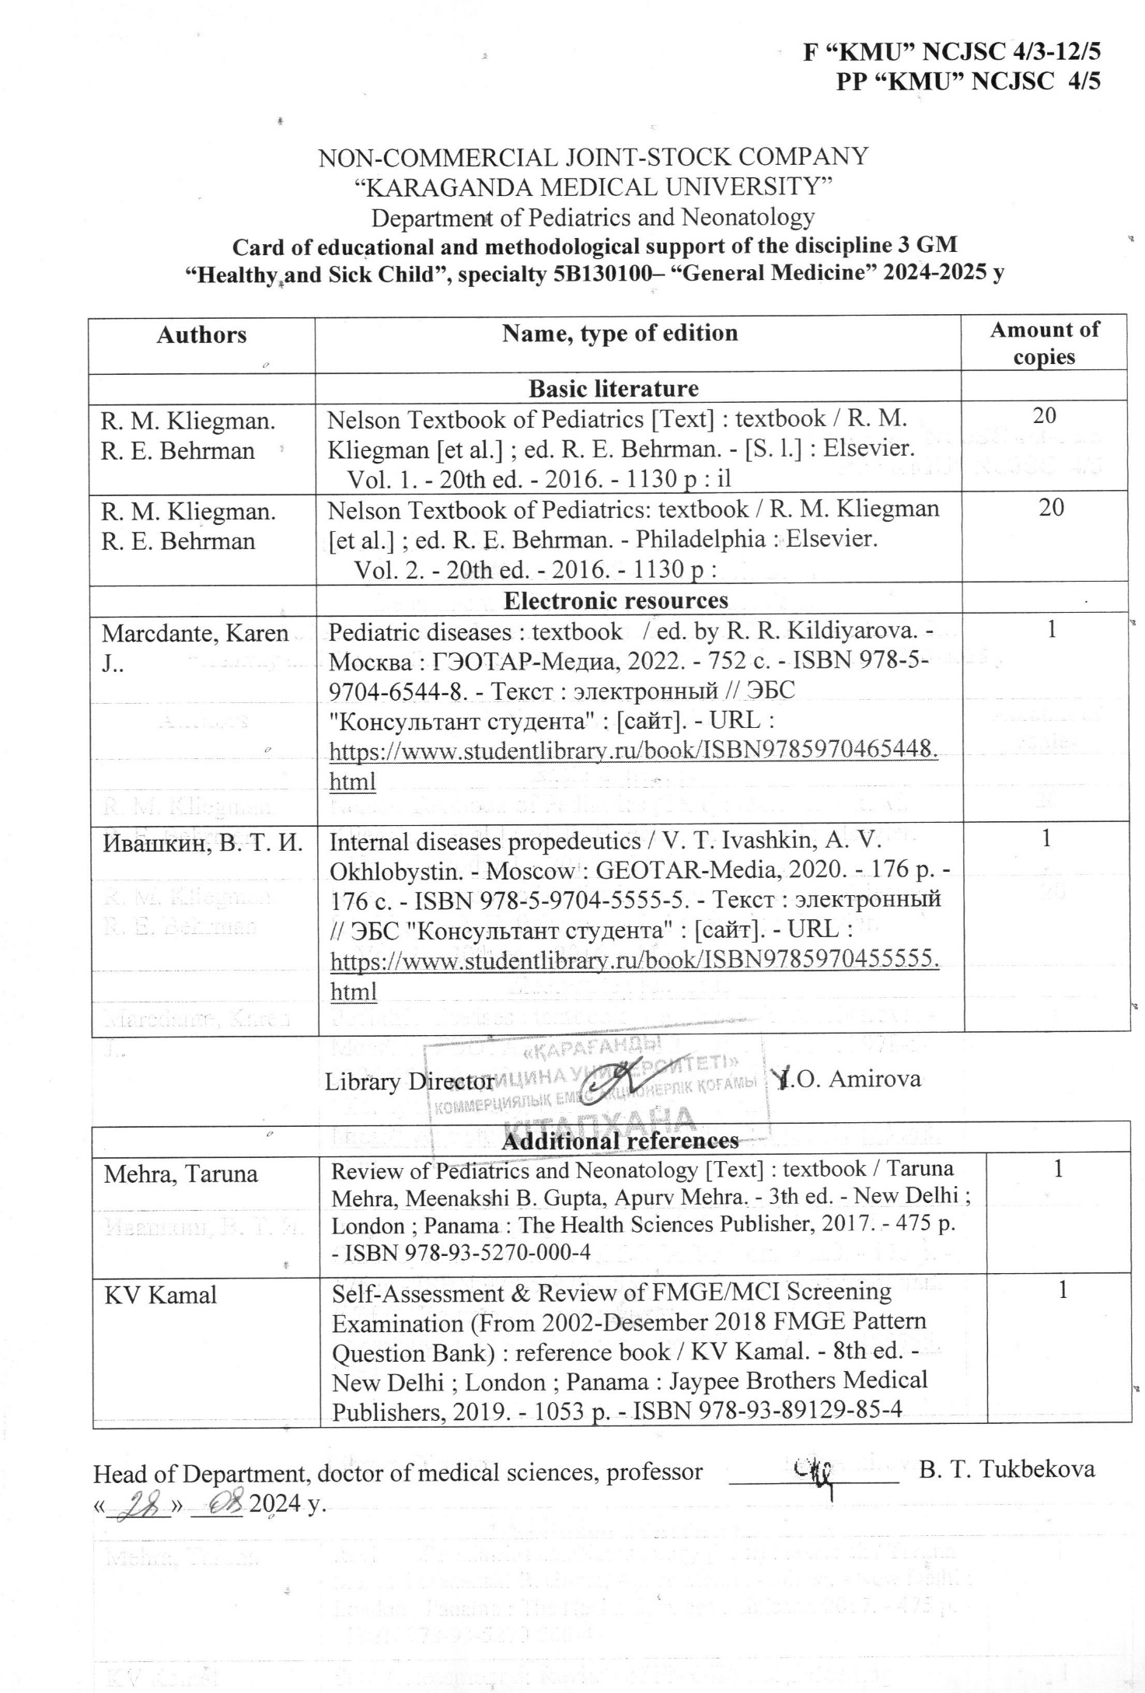

Application 2

Instrumentation by discipline Healthy and Sick Child
1. At the reception at the pediatrician in the clinic, a mother with a girl of 3 years old. The child is enrolled in a kindergarten. Body weight 15.1 kg, body length 98cm.
Exercise:
1. Specify the empirical formula for calculating body length over 1 year
2. Indicate the empirical formula for calculating body weight over 1 year
3. Estimate the length of the child's body.
4. Estimate the child's body weight
5. Evaluate the physical development of the child on the centile tables.

2. In a child of 8 months, palpation of the chest, the doctor found a thickening called "Harrison's groove". What pathological changes in bones are characteristic of this condition?
A. thickening of the epiphyses of the radial bones
B. thickening in the area of ​​the epiphyses of the fibula
C. thickening of the phalanges of the fingers
D. thickening of the occipital bones
E. thickening in the area of ​​transition of the bone part of the rib to the cartilaginous

3. The woman gave birth on time. The child's condition is satisfactory. Body weight at birth 3300 g, length 55 cm. The boy is attached to the chest after 6 hours. I took the breast well, feeding 7 times a day. Physiological weight loss by day 6 was 300g. By the 10th day of life, the body weight is 3100g.
Exercise
1. Specify the percentage of physiological loss of body weight
2. Estimate the physiological loss of body weight
3. Estimate the weight gain by the 10th day of life
4. Tactics?
5. Tips for the baby's mom?

4. When examining the muscular system, the following is assessed:
A. degree of muscle development
B. muscle relief
C. muscle tone and strength
D. relationship with antecedent trauma
E. motor activity of muscles
F. muscle volume
G. joint damage
H. local tenderness

5. The child is 2 years old. He was admitted to the department of respiratory pathology with complaints of fever up to 38 ° C, shortness of breath, wet, frequent cough. Objectively: a state of moderate severity. The skin is clean, pale, cyanosis of the nasolabial triangle is noted. Frequent, moist cough. In the lungs, percussion is a shortening of the pulmonary sound on the right in the suprascapular region. Auscultation: breathing is hard, weakened on the right, fine bubbling and crepitant rales are heard.
Exercise:
1. What parts of the respiratory system are affected?
2. Why are crepitant and small bubbling rales heard?
3. What is shortness of breath in this pathology?
6. Anatomical and physiological features of the larynx in young children
A. well developed submucosal layer
B. soft, pliable cartilage
C. short vocal cords
D. cylindrical shape
E. wide lumen
F. low position
G. well-developed vocal cords
H. cartilage elasticity
7. Name what determines the shallower depth of breathing in children:
A. small lung mass.
B. immaturity of the respiratory center
C. pronounced muscle development
D. better tolerance of hypoxia
E. structural features of the chest

8. The child is 10 years old. Complaints of pain in the right hypochondrium, nausea after eating fatty foods. On examination, the abdomen is soft. There is pain on palpation in the right hypochondrium. Positive symptoms of Kera, Murphy, Ortner. What instrumental research methods need to be carried out?
A. colonoscopy
B. angiography
C. Ultrasound of the gallbladder
D. reohepatography
E. endoscopy

9. The occurrence of dry wheezing in the airways is associated with:
A. vibration of filaments of viscous phlegm
B. the presence of liquid secretion in the bronchi
C. the presence of a foreign body in the main bronchus
E. accumulation of fluid in the pleural cavity
E. the appearance of inflammation in the lung tissue

10. Borders of cardiac dullness relative to the anterior surface of the chest with the age of the child:
A. expand
B. taper
C. do not change
D. deformed
E. rise

